The Travel Memory application has been developed using the MERN stack. Your challenge is to deploy this application on an Amazon EC2 instance. This will provide you with hands-on experience in deploying full-stack applications, working with cloud platforms, and ensuring scalable architecture.

Project Repository: Access the complete codebase of the TravelMemory application from the provided GitHub link: https://github.com/UnpredictablePrashant/TravelMemory
Travel Memory Deployment Architecture.
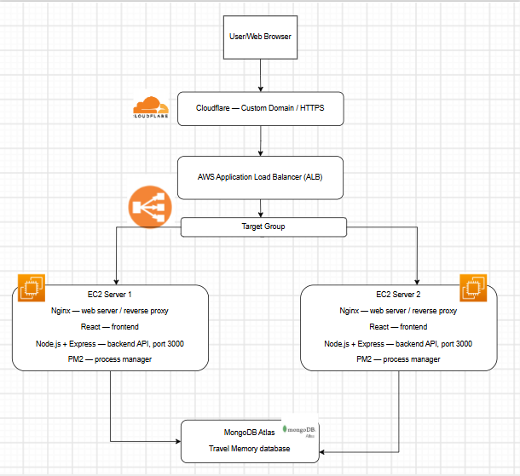

EC2_Instances
TravelMemory-Server and TravelMemory-Server-2
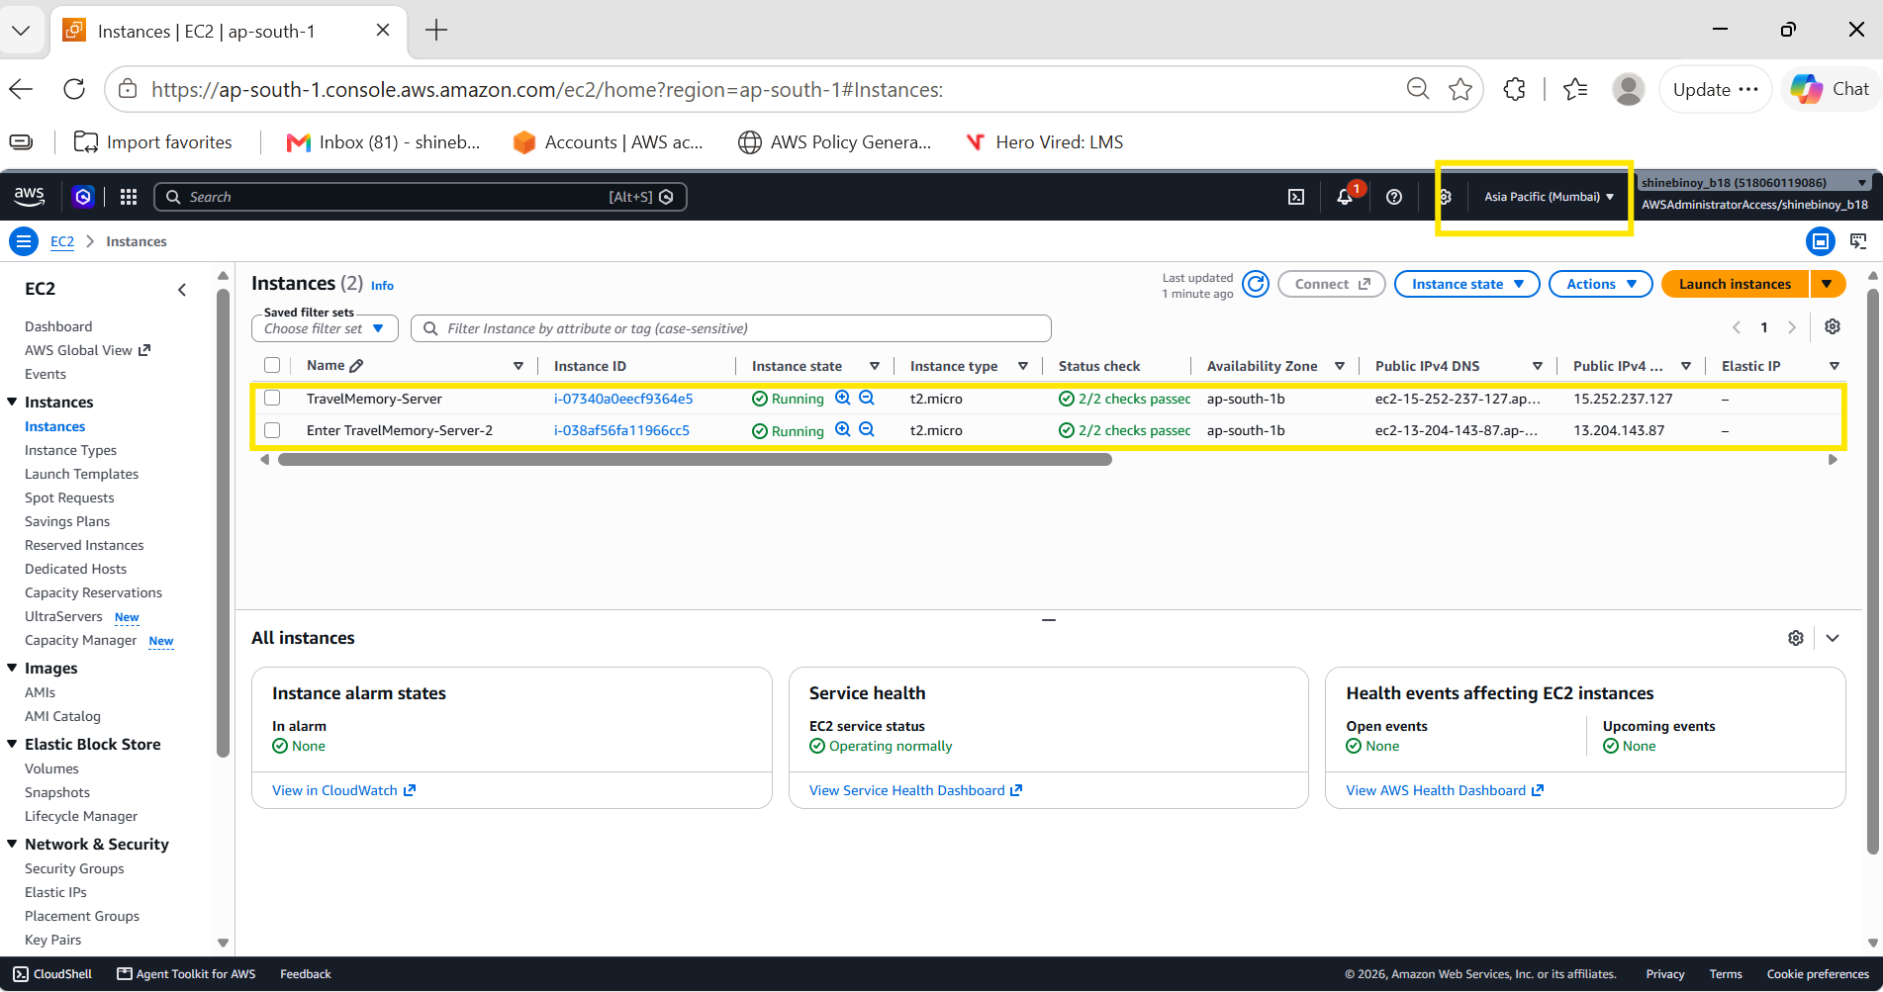

Load_Balancer
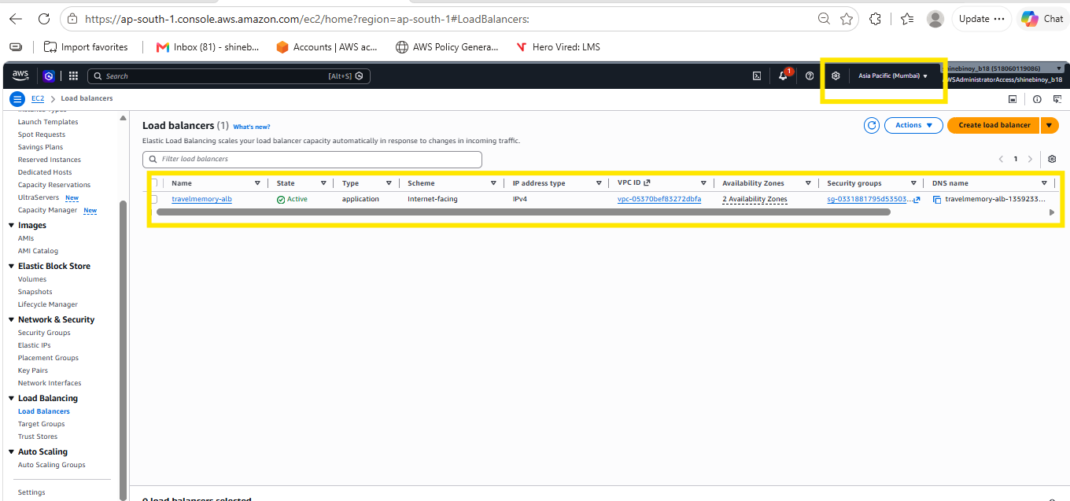
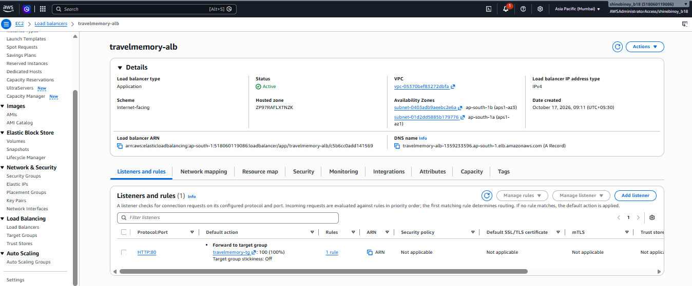

Target groups
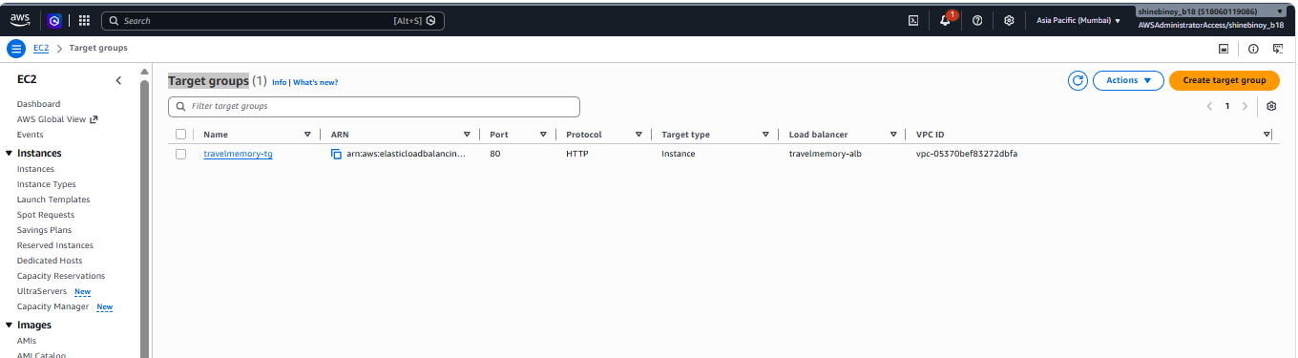

MongoDB Atlas
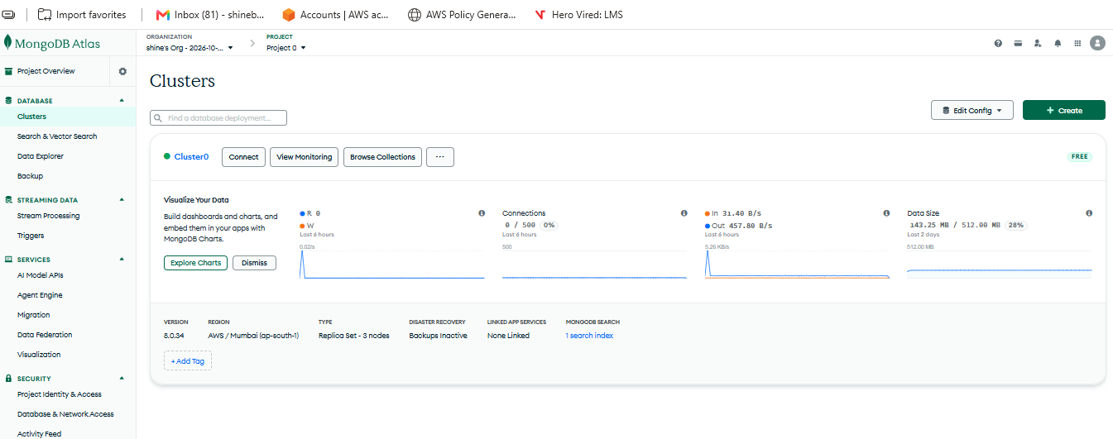
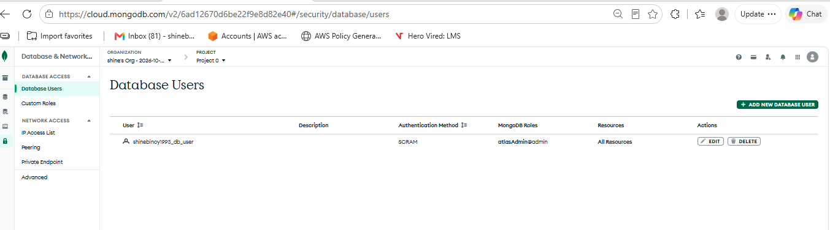

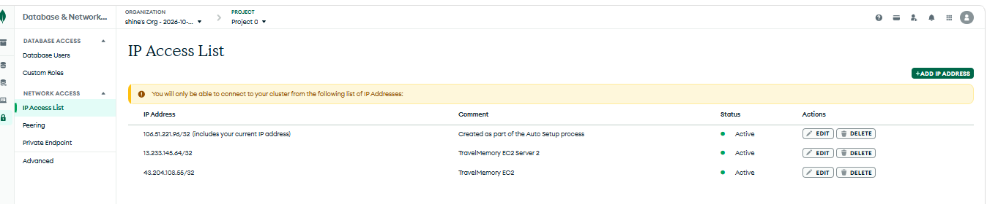

Cloudflare DNS configuration
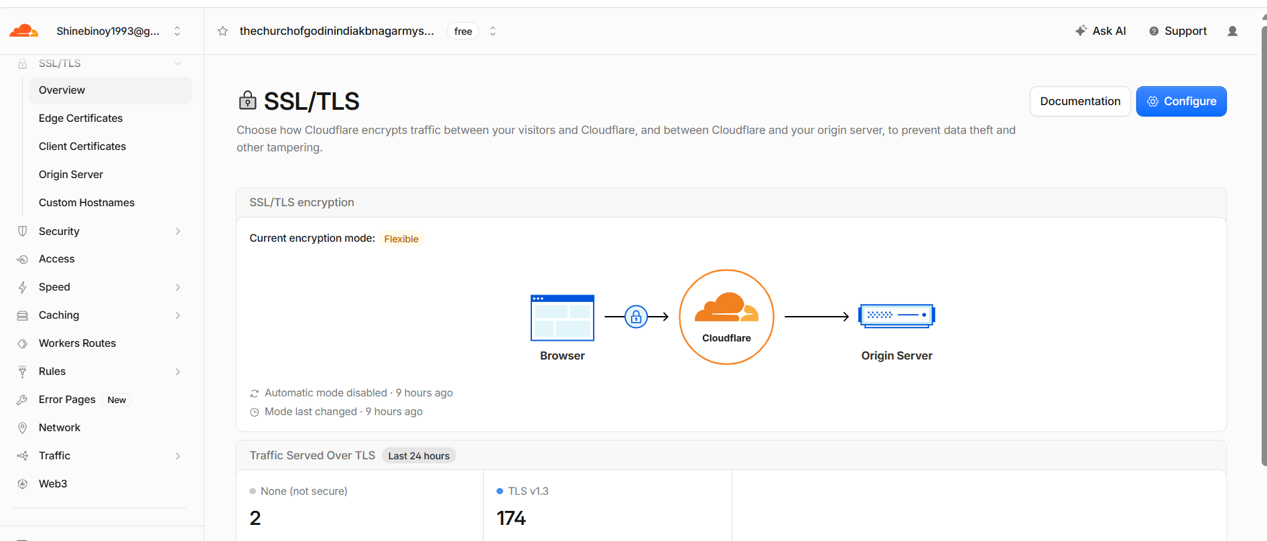
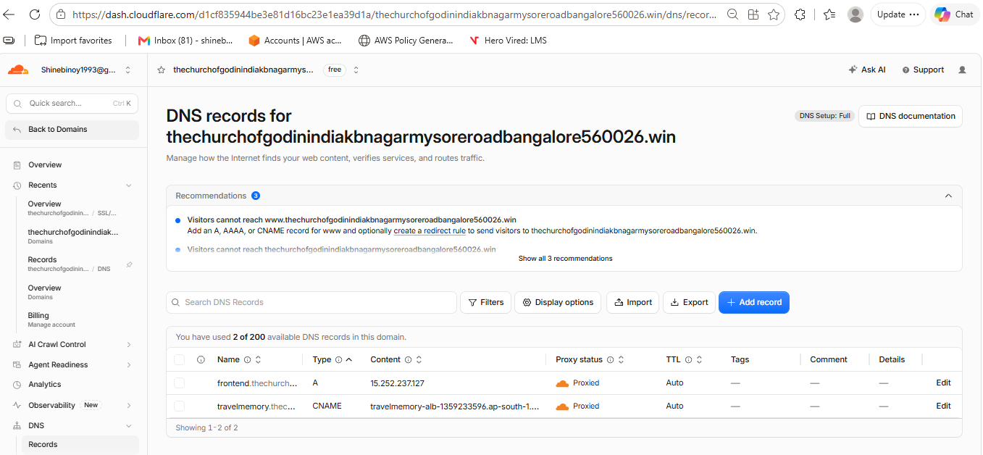

React App
Add Experience
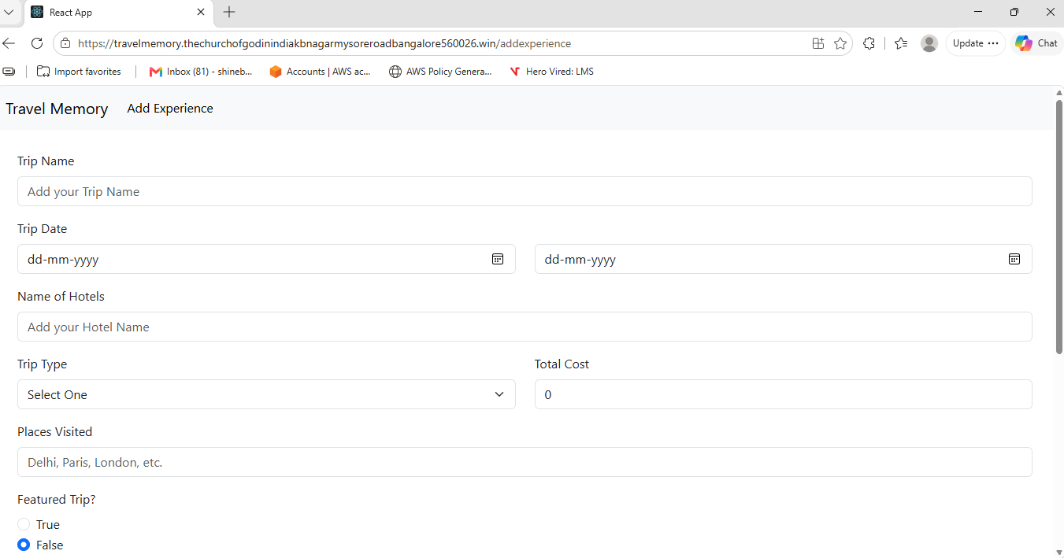
Travel Memory
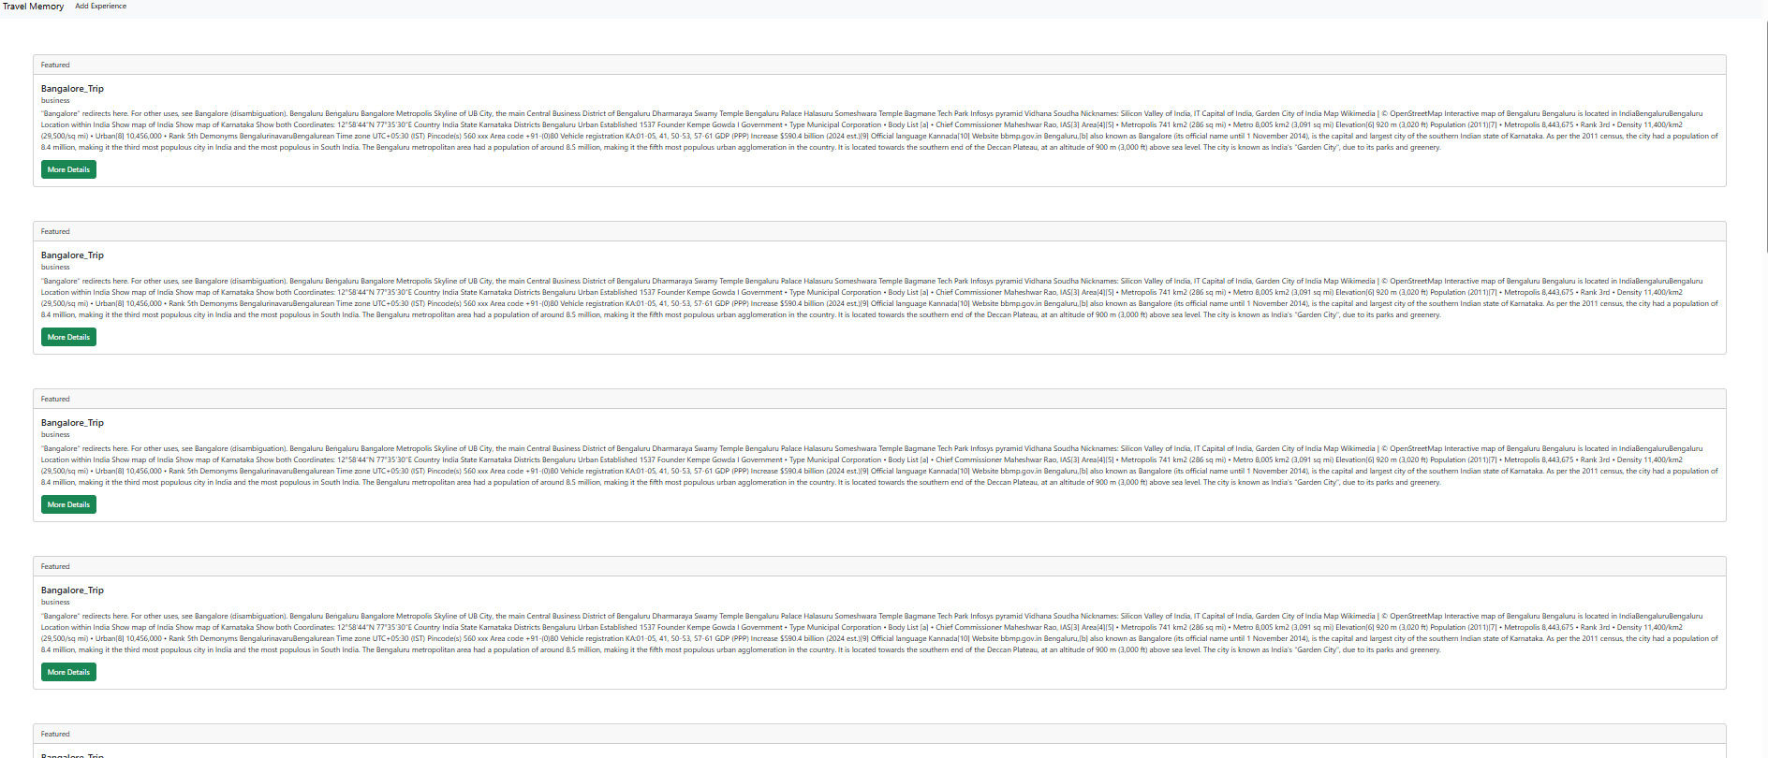
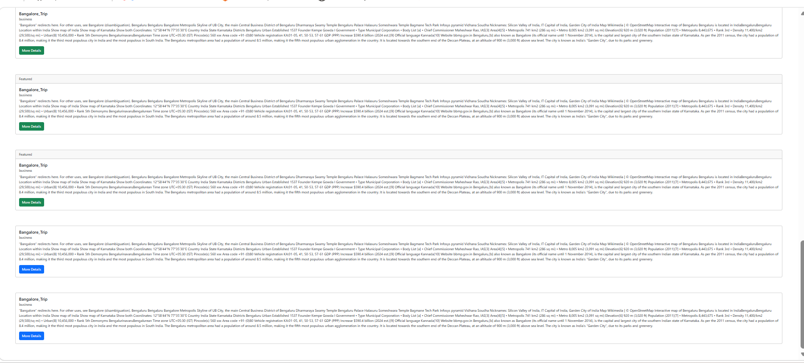

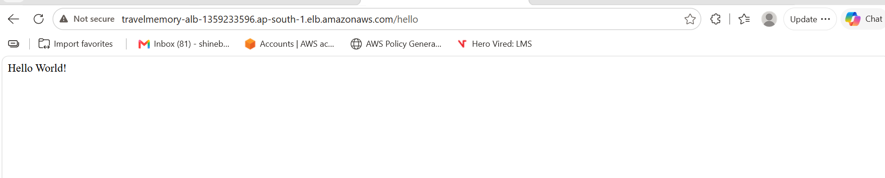

Front End
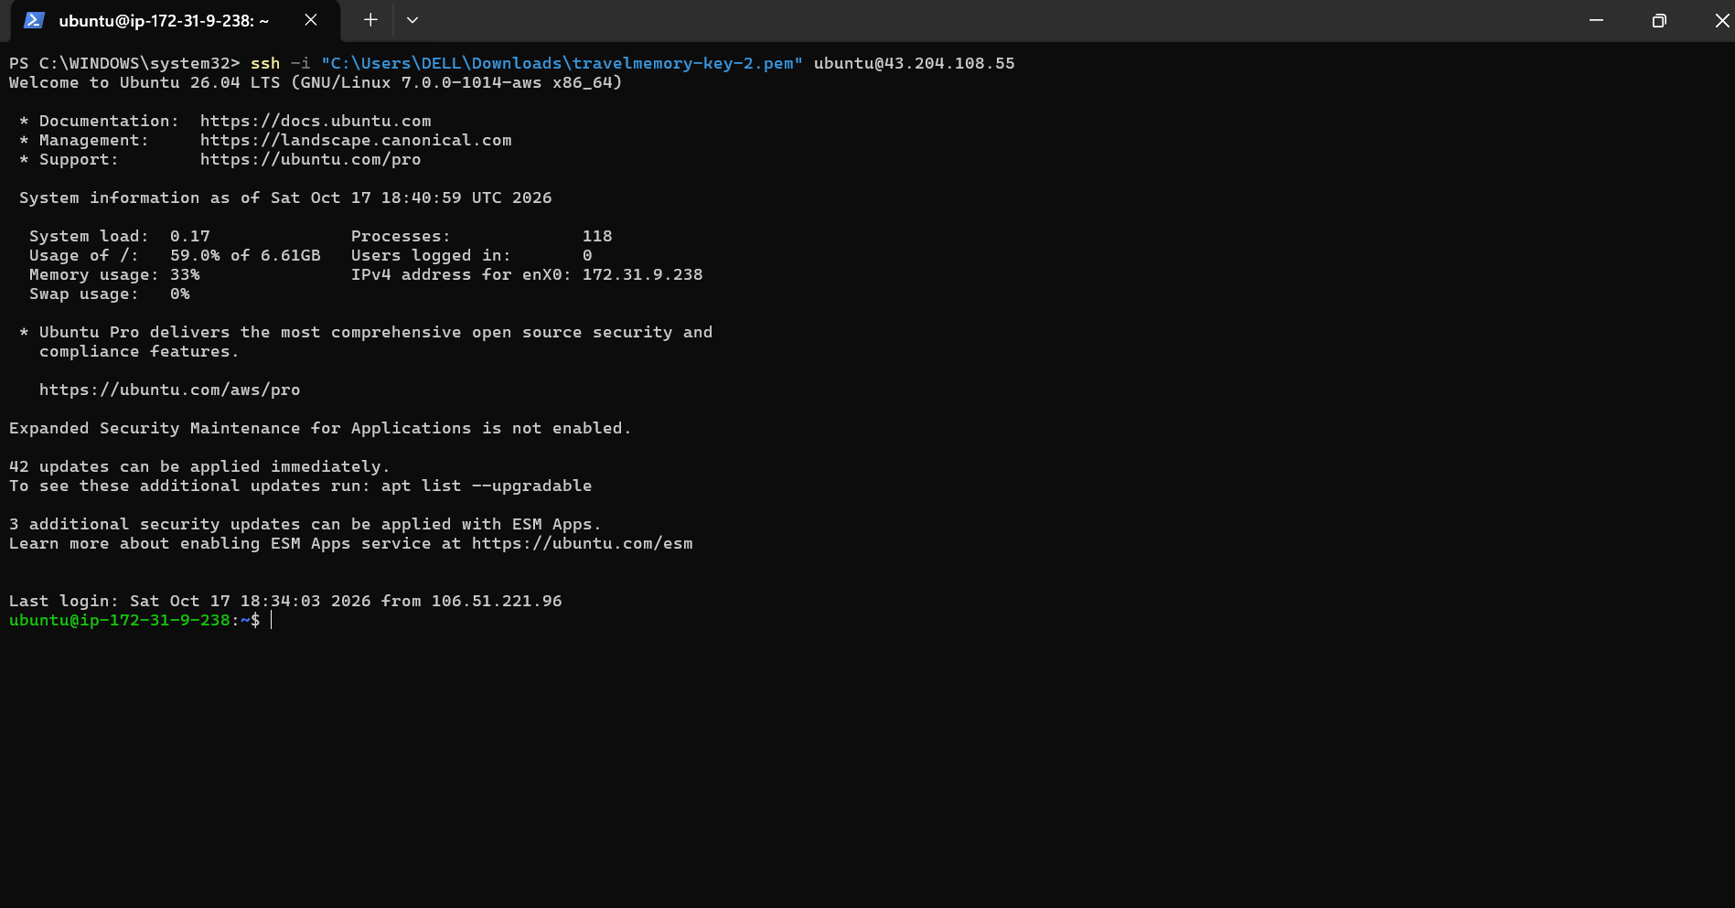

ubuntu@ip-172-31-9-238:~$ cd ~/TravelMemory
ubuntu@ip-172-31-9-238:~/TravelMemory$ sed -n '1,65p' frontend/src/components/pages/Home.js
import React, { useEffect, useState } from "react";
import Card from "../UIC/Card";
import FeaturedCard from "../UIC/FeaturedCard";
import axios from "axios";
import { baseUrl } from "../../url";

export default function Home() {
const [data, setData] = useState();
useEffect(() => {
axios.get(`${baseUrl}/trip/`).then((res) => setData(res.data));
}, []);
if (data) {
return (
<div style={{ margin: "2%" }}>
{data.map((e) => {
if (e.featured) {
return (
<FeaturedCard
title={e.tripName}
tripType={e.tripType}
description={
e.shortDescription && e.shortDescription.length > 180
? e.shortDescription.substring(0, 180) + "..."
: e.shortDescription
}
id={e._id}
></FeaturedCard>
);
} else {
return null;
}
})}
{data.map((e) => {
if (!e.featured) {
return (
<Card
title={e.tripName}
tripType={e.tripType}
description={
e.shortDescription && e.shortDescription.length > 180
? e.shortDescription.substring(0, 180) + "..."
: e.shortDescription
}
id={e._id}
></Card>
);
} else {
return null;
}
})}
</div>
);
} else {
return <>Loading...</>;
}
}
ubuntu@ip-172-31-9-238:~$ cd ~/TravelMemory
ubuntu@ip-172-31-9-238:~/TravelMemory$ sed -n '1,65p' frontend/src/components/pages/Home.js
import React, { useEffect, useState } from "react";
import Card from "../UIC/Card";
import FeaturedCard from "../UIC/FeaturedCard";
import axios from "axios";
import { baseUrl } from "../../url";

export default function Home() {
const [data, setData] = useState();
useEffect(() => {
axios.get(`${baseUrl}/trip/`).then((res) => setData(res.data));
}, []);
if (data) {
return (
<div style={{ margin: "2%" }}>
{data.map((e) => {
if (e.featured) {
return (
<FeaturedCard
title={e.tripName}
tripType={e.tripType}
description={
e.shortDescription && e.shortDescription.length > 180
? e.shortDescription.substring(0, 180) + "..."
: e.shortDescription
}
id={e._id}
></FeaturedCard>
);
} else {
return null;
}
})}
{data.map((e) => {
if (!e.featured) {
return (
<Card
title={e.tripName}
tripType={e.tripType}
description={
e.shortDescription && e.shortDescription.length > 180
? e.shortDescription.substring(0, 180) + "..."
: e.shortDescription
}
id={e._id}
></Card>
);
} else {
return null;
}
})}
</div>
);
} else {
return <>Loading...</>;
}
}
ubuntu@ip-172-31-9-238:~/TravelMemory$ cd ~/TravelMemory
ubuntu@ip-172-31-9-238:~/TravelMemory$ sed -n '1,65p' frontend/src/components/pages/Home.js
import React, { useEffect, useState } from "react";
import Card from "../UIC/Card";
import FeaturedCard from "../UIC/FeaturedCard";
import axios from "axios";
import { baseUrl } from "../../url";

export default function Home() {
const [data, setData] = useState();
useEffect(() => {
axios.get(`${baseUrl}/trip/`).then((res) => setData(res.data));
}, []);
if (data) {
return (
<div style={{ margin: "2%" }}>
{data.map((e) => {
if (e.featured) {
return (
<FeaturedCard
title={e.tripName}
tripType={e.tripType}
description={
e.shortDescription && e.shortDescription.length > 180
? e.shortDescription.substring(0, 180) + "..."
: e.shortDescription
}
id={e._id}
></FeaturedCard>
);
} else {
return null;
}
})}
{data.map((e) => {
if (!e.featured) {
return (
<Card
title={e.tripName}
tripType={e.tripType}
description={
e.shortDescription && e.shortDescription.length > 180
? e.shortDescription.substring(0, 180) + "..."
: e.shortDescription
}
id={e._id}
></Card>
);
} else {
return null;
}
})}
</div>
);
} else {
return <>Loading...</>;
}
}
ubuntu@ip-172-31-9-238:~/TravelMemory$
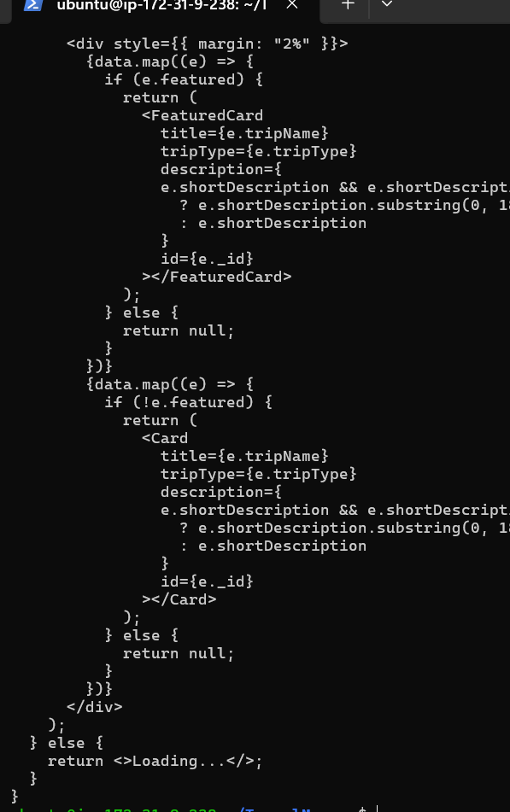
Back End
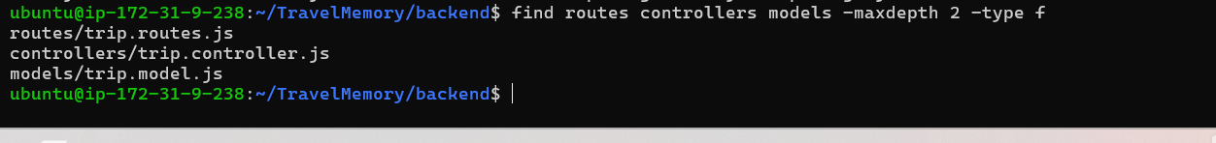backend controller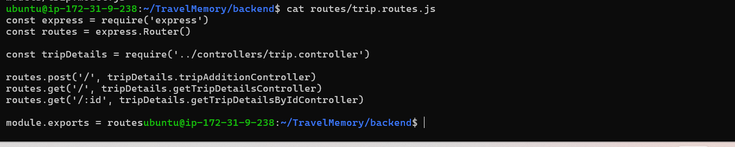
API
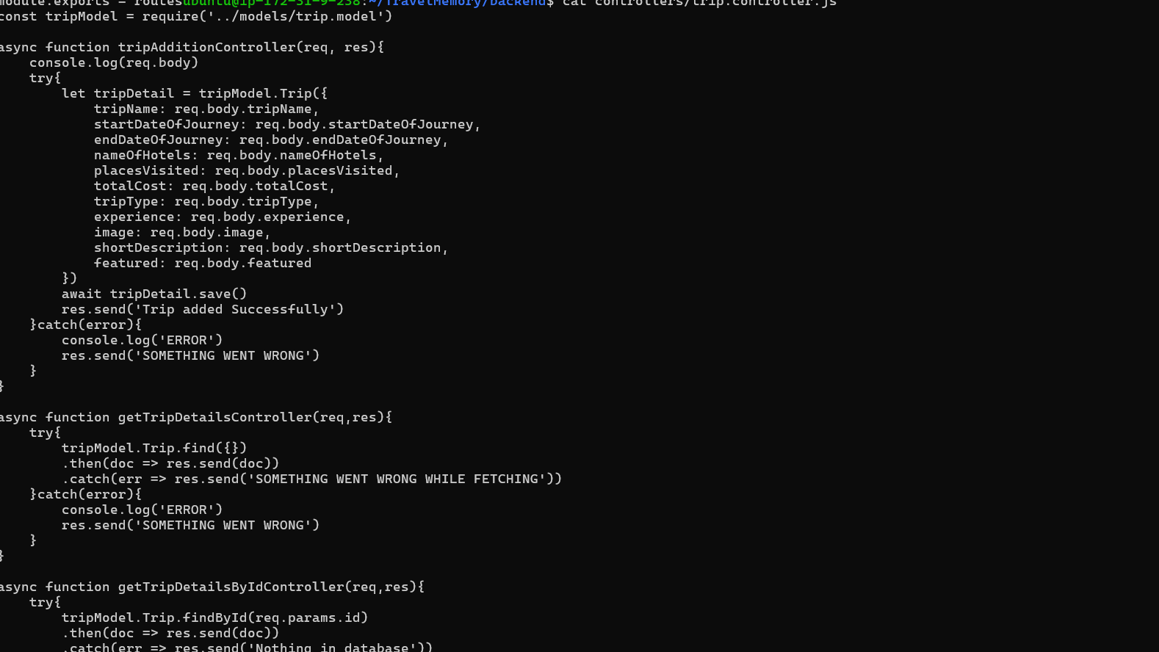
MongoDB data model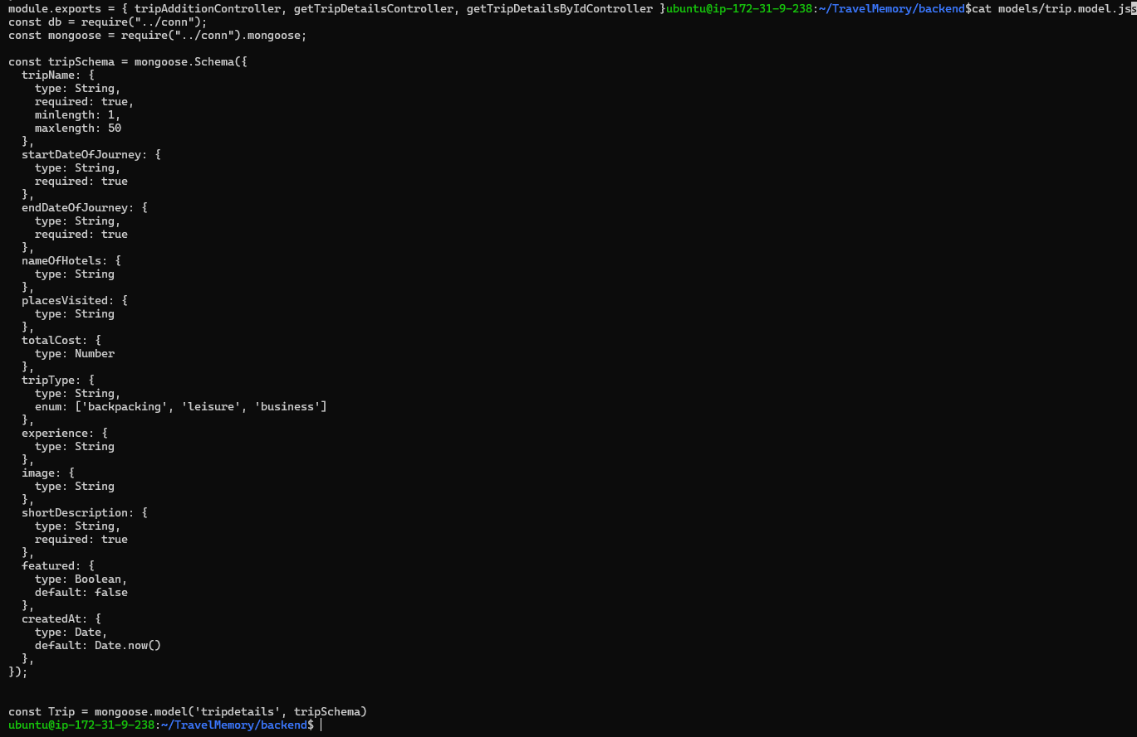
Node.js backend running status
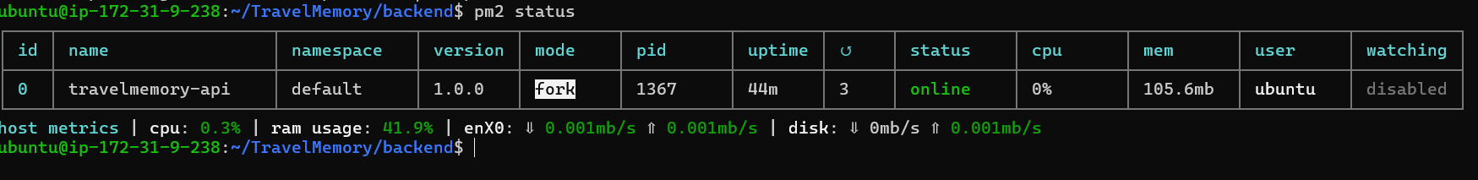
Nginx configuration
